Smart Soles

Navigation for the Differently Abled

I wish to build an IoT connected insoles to assist the differently-abled population (sight or sound impaired, for instance) safely navigate to their destination using directions provided in the form of haptic feedback from the shoes.

My idea of this device would consist of the following:

* 4 x Vibrating motor (or any low current motor) – two in each shoe
* 2 x Motor Drivers – each can drive up to 3 motors
* Wi-Fi chip to fetch instructions from a server – these instructions will trigger the motors when user needs to change their trajectory
* GNSS / GPS chip to get position of the user – this is a necessary input in determining when to activate the motors

**Considerations**: If GPS turns out to be too expensive, can be figure out a lower cost alternative to localize the user using Wi-Fi perhaps? The tradeoff would be cost vs. accuracy.

**Simple System Diagram**

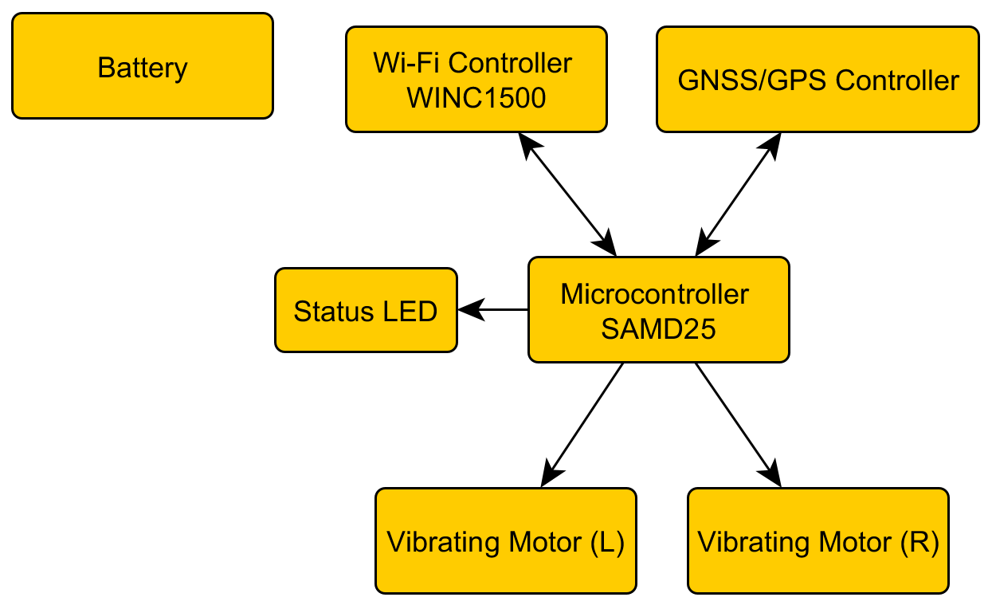

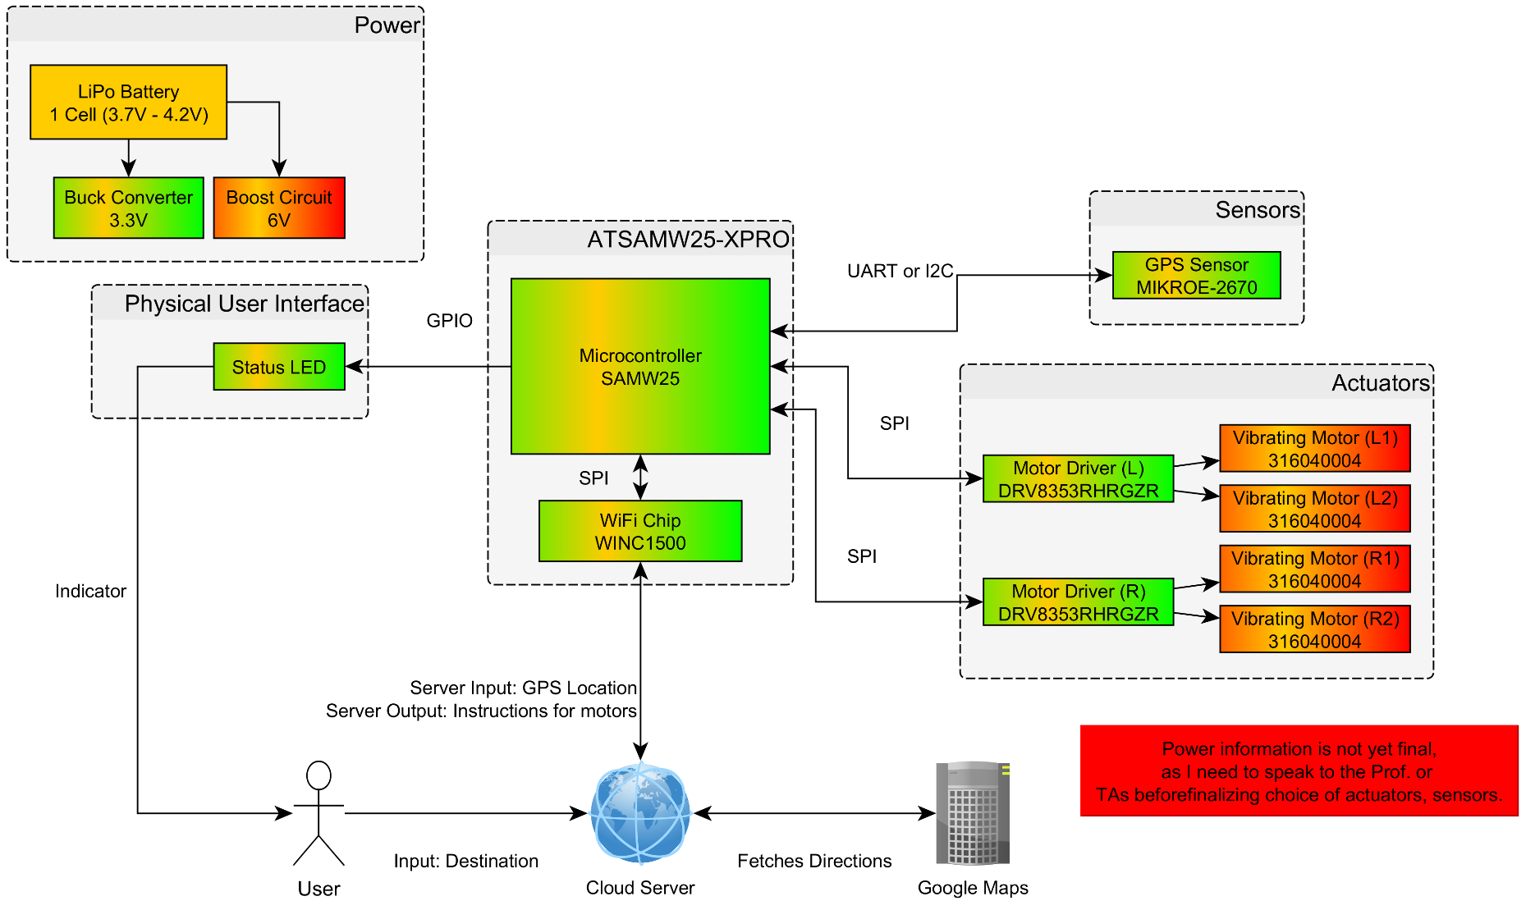**Detailed System Diagram**

4.) Detailed System Diagram [50/50]

COMMENTS:

1.) Good description of the problem and good analysis of the technical challenges. Indeed! Location of a person on a building is a very hard problem - GPS can have issues inside buildings and usually has a tolerance that is ok to drive cars with, but it is too big for people walking inside buildings. There are some radios that try to do this location, but it is a hard problem. I worry that the product, as is ideally thought of, might be too hard to implement for this class. Let's talk after class this monday!

3.) The motor drivers are SPI drivers for thee phase BLCD motors. That is some serious motor controller! The vibrating motors you selected do not need this very complicated motor driver. For these motors, you can use either a simple BJT (turn on/off) or even more interesting, a haptic driver. Haptic driver are specialized drivers that allow you to do cool stuff with haptics. Check for example which is a better fir for your product.

https://www.adafruit.com/product/2305